End-to-End Design
Master Test Plan
UID 8335 – BB Case Management

Version: 0.2
Date: <02 05 2019>

Tick Relevancy | This artefact is a………………
✓ | Template
 | Guideline
 | Standard
 | Other

Tick Relevancy | Draft | Reviewed | Approved
Status | ✓

 | Owner | Author | Reviewer | Authoriser
Name | Josina Matsepa | Josina Matsepa | Andrew Miller | Tania Day
Designation | Test Manager | Test Manager | Senior Test Manager | Business Analyst
Signature
Date
Name  Designation  Signature  Date |  |  |  | Douw Snetler  Project Manager
Name |  |  |  | Mariette Meyer
Designation |  |  |  | Head: National Credit Centre
Signature
Date

Version | Detail of Change Made | Date Change Made
0.1 | Initial Draft Version
0.2 | Updated test scope based on feedback from Tania Day | 03/05/2019

TABLE OF CONTENTS

1. Introduction 5
1.1 Identification 5
1.2 References 5
2. Background 6
2.1 Overview 6
2.2 Current system environment 6
2.3 Project Goals 6
3. Test Objectives 7
4. Test Scope 8
5. Assumptions 9
6. Test Strategy 10
6.1 Risk Assessment 10
6.2 Test Focus Areas 10
6.3 Levels of Testing 11
6.4 Entry / Exit Criteria 12
6.5 Functional and Structural Test Types 13
7. Test Plan 15
7.4 Test Schedule 17
7.5 Major testing milestones 17
7.6 Resource requirements 18
7.7 Contingencies 18
8. Test Environment Build Strategy 19
8.1 Test Data Strategy 19
9. Test Management & Reporting Procedures 21
9.1 TEST MANAGEMENT 21
10. Appendix 24
10.1 Severity Codes Definition 24

Introduction

This document is the Test Plan for BB Case Management. It outlines at a broad level the scope and testing activities that will be conducted on the project, the strategies and methodology that will be adopted for the Project.
The Project will be delivered in two phases:
- Phase 1 – BB Case Management NOT integrating to ECM for documents storage and retrieval
- Phase 2 - BB Case Management integrating to ECM for documents storage and retrieval
The purpose of this document is to communicate the approach that will be employed in conducting the BB Case Management testing effort; the test effort will be limited to the defined in the Scope section below.
- Detail of scope for the testing activity.
- Assumptions and identification of risks for the testing.
- Define, design and provide deliverables for the testing.
- To ensures management and business stakeholders that the test team is providing adequate test coverage
- To inform management about status, test progress, schedules and resource utilization during test life cycle of this Release.

This document will form a guideline for the test team as well as project team on testing activities. The intended audience of this document are the project team members and all other impacted testing and business areas.

Identification
This document describes the Master Test Plan for the engagement BB Case Management Phase 1.

References
This document is based on and refers to the following documents:
[1] Jira link - http://jira.nednet.co.za/secure/RapidBoard.jspa?rapidView=2307&projectKey=UID8335&view=detail&selectedIssue=UID8335-54
[2] User Stories document
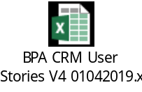

Background
The purpose of the project is to implement a solution that will manage the workflow between the Front- Line Customer Service Teams (CST), Credit Assessment Teams and the National Credit Centre within Business Banking. The project will implement the “Credit Support Centre” and reduce the credit administration. By implementing the credit support centre, the project will be able to reduce the current administrative tasks within the CST as per the approved business case.

Overview
Business Banking Case Management is divided into two Phases:
2.1.1 Phase 1
Case Management with no integration to ECM for document storage and retrieval. Documents will be stored in Sharepoint. Sharepoint links will be attached to the case for document retrieval.
2.1.2 Phase 2
Case Management integrating to ECM for document storage and retrieval.

Current system environment

TBC

Project Goals

- To automate the flow of work (including supporting documents), within the National Credit Support Centre.
- To improve traceability of work, ensure SLA’s are met, improve user and client experience through improved turn-around times, hence reducing operating costs.
- To centralise current administrative tasks.
- To set-up the centralised team in Lakeview including desk allocations and PC configurations etc.
- To re-engineer all Business Banking Credit Support Centre processes and where applicable document the end-to-end processes.
- To streamline current work and processes, by removing work / processes that do not add value.
- To provide a document storage solution.

Test Objectives

- To ensure that any defects in the requirement documentation are found and removed as early in the software development lifecycle as possible (early static testing of requirements)
- To ensure that the requirements are thoroughly tested, and that the results align to the stakeholders requirements
- To ensure that the quality of the solution has been assessed by ensuring that all the business processes undergo full end-to-end system testing
- To identify and communicate all system defects and discrepancies discovered before or during the system test phase to the project team, and ensure that all issues are addressed in an appropriate manner before implementing into production
- To identify and expose all issues and associated risk via regular reporting of test progress and test metrics
- To ensure that the entry and exit criteria of system testing are achieved
- To ensure that the software satisfies the release criteria, as specified by Nedbank’ s release and change management team
- To ensure that for every mandated system change there will be a corresponding testing activity

Test Scope
In Scope for Phase 1
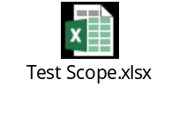
Out of Scope for Phase 1
- Non-Functional Testing is not in scope for Phase 1
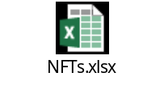
- Integration to ECM for Documents storage and retrieval
- Integration to CIS/MDM for real-time data feeds

Assumptions

- All required systems will be available in ETE and QA
- Deployments for the respective stories will be staggered into ETE
- Deployment to QA will follow big bang
- Development team will provide extract of test data as the system is not integrated to CIS/MDM and BI Portal for real-time feeds
- Testing will include only web browsers and operating system versions approved by business.
- All up to date project documentation has been stored in a central repository and will be made available to the testing team.
- The project will follow formal change control processes. However, exemptions for Governance Process for Agile Projects must be in place.
- Environments available are DEV, ETE for Solution Verification Testing and UAT will be conducted in QA environment.
- Solution Verification Testing will be carried out on Primary Browsers in ETE and QA
- This approach will be reviewed over time based on the defects found.
- All stories or requirements will be documented in Jira.
- Jira will be used for defect management.
- Testing will take place at 135 Rivonia Road.
- Business users will conduct production Testing.

Test Strategy
The overall Test Management, of all testing activities relating to solution verification testing and user acceptance testing of BPA project will be co-ordinated by the Test Manager from BEAT Team. The key objective of these tests will be to ensure that the delivered application behaves as described in the user stories/ business requirements as well as ensure that all exposed flaws in the underlying components or system are fixed. BEAT Testing Team will form part of the squad and will perform solution verification testing and UAT testing, including user story/requirements review, test case design and execution.

Risk Assessment
- Scope Changes
- In order to implement the Master Test Plan effectively, the test environments should be stable and integrate to the correct systems and interfaces
- Any delays in the delivery of completed code into the test environment will affect the testing timelines and final release quality.
- Continuous changes to business requirements may result in functional issues while testing.

Test Focus Areas

- Auditability - Ability to provide supporting evidence to trace processing of data.
- Continuity of Processing - Ability to continue processing if problems occur. Include the ability to backup & recover after failure.
- Correctness - Ability to process data according to prescribed rules. Controls over transactions and data field edits provide an assurance on accuracy and completeness of data.
- Maintainability - Ability to locate and fix an error in the system. Can also be the ability to make dynamic changes to system environment without making system changes.
- Operability - Effort required to learn and operate the system (can be manual or automated).
- Performance - Ability of the system to perform certain functions or process certain volumes of transactions within a prescribed time.
- Portability - Ability for a system to operate in multiple operating environments.
BB Case Management Solution must be compatible with the following Operating Systems and Browsers

Operating Systems | Browser
Windows 7 | IE 11
Windows 10 | Edge

- Reliability - Extent to which system will provide the intended function without failing.
- Security - Assurance that the system/data resources will be protected against accidental and or intentional modifications or misuse.
- Usability - Effort required to learn and use the system.

Levels of Testing
6.5.1 Unit Testing
The objectives of Unit Testing is ensure that individual programs, modules, or components are tested to demonstrate that work package executes per specification; validate technical quality of application. Focus on ensuring that detailed logic within components is accurate and reliable according to pre-determined specifications. Testing stubs or drivers may be used to simulate behaviour of interfacing modules. The Development teams will conduct Unit Testing in DEV.

6.5.2 Development Integration Testing
The objective of Development Integration Testing is to ensure that transactions flow accurately and effectively from the front end via middleware (services) to the back-end. Testing will expose defects in the interfaces and in the interactions between integrated components or systems. This test begins after developers have completed their unit and system tests. It will be conducted by the Development teams, to ensure successful integration of all components. The Development team will ensure that the end-to-end solution, functions in accordance with the solution and requirements defined by the project

6.5.3 Solution Verification Testing
The entire system is tested to verify that all functional, information, structural and quality requirements have been met. A predetermined combination of tests is designed that, when executed successfully, satisfy management that the system meets specifications. The Testing Team execute this level of testing in ETE.
6.5.4 User Acceptance Testing
The objective of UAT is to ensure that the system meets the needs of the organisation and the end user/customer. The customer executes this level of testing in the QA. It validates that the system will work as intended by the user in the real world, and is based on real world scenarios.
Test Level | Environment | Responsible Area | Accountable Person
Unit and Development Integration Testing | DEV | Development Team | Natasha Hatcheson
Solution Verification Testing | ETE | BEAT Testing Team | Josina Matsepa
User Acceptance Testing | QA | BEAT Testing Team | Josina Matsepa

Entry / Exit Criteria

6.6.1 Solution Verification Testing - Entry and Exit Criteria

Entry Criteria
- ETE test environment available
- Code and hardware received from Development team. – Development Team make Env available
- Release notes detailing scope of stories being deployed.
- Test accounts have been made available
- Appropriate Access granted
- Unit Testing
- Test cases and test plan documented and signed off

Exit Criteria
- Defined tests executed
- Test Results documented and approved.
  - Test cases.
  - Test results.
  - 90 % Pass,
  - No priority 1 & 2 defects outstanding
- All critical defects reported addressed. –Risk assessment done on remaining defects to understand possible impact.
- All agreed defect fixes implemented and re-tested.
- Regression testing completed if required

6.6.3 User Acceptance Testing - Entry and Exit Criteria

Entry Criteria – UAT
- UAT (QA) test environment available
- System test cases.
- User accounts have been defined and are available
- Solution Verification Testing test results reviewed and approved by Business
- 90% Pass on test case
- No severity 1 & 2 defects outstanding
- Defect tracking process available
- Solution is working end to end

Exit Criteria into PROD
- User acceptance testing executed.
- User acceptance testing results documented and approved.
- Business requirements have been met or renegotiated with the Business Sponsor or representative
- Business community and operations impacted by changed have received training, communication and
- Defects
  - Known defects have been documented. All defects reported addressed.
  - Risk assessment done on remaining defects to understand possible impact to production (technical and business).
  - All agreed defect fixes implemented and re-tested.
  - Business sponsor and technical stakeholders agree that known defects do not impact a production release—no remaining defects are rated severity 3, 2, or 1
- Implementation and Change Control
  - Implementation Plan fully documented
  - Deployment and back-out testing has been performed and documented and the results have been signed off
  - All tests show that the application will not adversely affect the production environment
  - A Change Control Records with approvals has been prepared
  - Security requirements have been documented and necessary user access obtained
  - Change control is managing requested modifications and enhancements

Functional and Structural Test Types

Functional Types of Test
The following functional types of tests are applicable:
- Audit and Controls - Verifies the adequacy and effectiveness of controls and completeness of data processing results.
- (User) Documentation and Procedures - Verifies that the interface between the system and the people works and is useable. Verifies that the instruction guides are helpful and accurate.
- Error Handling - Verifies the system function for detecting and responding to exception conditions. Completeness of error handling determines the usability of a system and ensures that incorrect transactions are properly handled.
- Function - Verifies that each business function operates according to the Detailed Requirements, the External and Internal Design documents.
- Interface / Inter-system - Verifies that the interconnection between applications and systems functions correctly.
- Regression - Verifies that, as a result of making changes to one part of the system, unwanted changes were not introduced to other parts.
- Transaction Flow (Path) - Verifies the proper and complete processing of a transaction from the time it enters the system to the time of its completion or exit from the system.
- Usability - Verifies that the final product is user-friendly and easy to use.

Structural Types of Test
The following structural types of testing are applicable:
- Backup and Recovery - Verifies the capability of the application to be restarted after a failure.
- Contingency - Verifies that a crucial application and its databases, networks, and operating processes can be recovered after a major outage or disaster.
- Job Stream - Verifies the execution of job streams and the correct handling of exceptions.
- Operational - Verifies the ability of the application to operate at an acceptable level of service in the production-like environment.
- Performance - Verifies that the application meets the expected level of performance in a production-like environment.
- Security - Verifies that the application provides an adequate level of protection for confidential information and data belonging to other systems.
- Stress/Volume -Verifies that the application has acceptable performance characteristics under peak load conditions.

Test Plan

7.1 DYNAMIC TEST APPROACH
The approach Testing will take to ensure that each deployment and feature is adequately tested is by using the business requirement documents and system design documents to define, review and execute test cases, to test the software, the results of which will be compared against pre-specified expected results, to evaluate whether the test was successful. At the end of the project cycle, the user should find that the project has met or exceeded all of their expectations as detailed in the requirements.
Any changes, additions, or deletions to the requirements document, or Design Specification will be documented and tested at the highest level of quality allowed within the remaining time of the project and within the ability of the test team. The test team will use manual testing to achieve the testing goals.
7.2 TEST EXECUTION APPROACH
The diagram below depicts the methodology to be followed by Test team to manage Solution Verification Testing
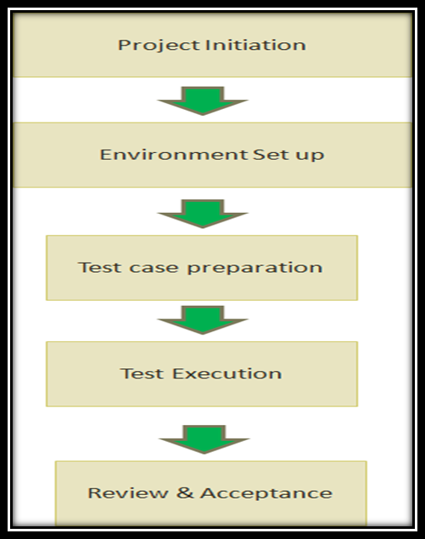

7.3 STATIC TEST APPROACH

Artefact |  | Static Testing Technique | Participants
Project Artefacts | Requirements Documentation/User Stories | Walkthrough | Business  Testing  PPM  Technical Teams  Solution Designers
Testing Artefacts | Test Plan | Walkthrough | Business  Testing  PPM  Technical Teams  Solution Designers
Testing Artefacts | Test Cases | Walkthrough | Business  Testing  PPM  Technical Teams  Solution Designers
Testing Artefacts | Test Defect Log | Walkthrough | Business  Testing  PPM  Technical Teams  Solution Designers
Testing Artefacts | Test Results | Walkthrough | Business  Testing  PPM  Technical Teams  Solution Designers

7.4 Test Schedule
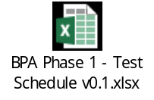

7.5 Major testing milestones

Solution Verification Testing
- All required systems and/or components for testing in ETE
- All planned test cases executed
- Solution Verification Testing Artefacts Signed off
User Acceptance Testing
- All required systems and/or components for testing in QA
- All planned test cases executed
- Solution Verification Testing Artefacts Signed off

7.6 Resource requirements

The table below depicts resource requirements:
Area | Role | NO of Team Members
BEAT Testing Team | Test Manager | 1
BEAT Testing Team | Test Analyst | 2

7.7 Contingencies
- Change Management process will be applied to assess impact of change to schedule, effort and cost.
- Test environment requirements to be understood and allow sufficient time to set up the test environment. Focus sessions to be scheduled for any down time in environment
- Test plan and approach to be revised and updated to mitigate risk
- Technical impact to be assessed. Deployment checklist to be discussed in Go/No Go meeting.

Test Environment Build Strategy
An adequate Test Environment must exist that accurately replicates the future Production Environment as far as possible. This can be a small-scale replica, but it must consist of the same types of hardware, programs and data configurations.
All systems impacted by the project must be available in DEV, ETE and QA.

Test Data Strategy

Solution Verification Testing in ETE
As the solution will not be integrated to CIS/MDM and BI Portal for Phase 1 to get real time data, the development team will provide test data that is on the data extract that the system uses.
User Acceptance Testing in QA
As the solution will not be integrated to CIS/MDM and BI Portal for Phase 1 to get real time data, the development team will provide test data that is on the data extract that the system uses.

8.2 CODE MIGRATING PATH
The migration path is depicted in the diagram below:
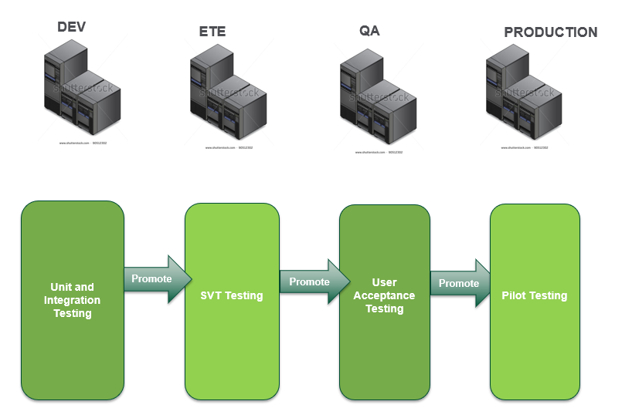

Test Management & Reporting Procedures

9.1 TEST MANAGEMENT
As this is an iterative/agile project, the testing team will become part of the team and attend daily stand-up meetings were regular feedback will be provided on the progress of testing. All tests status reports and dashboards will be kept updated on Jira.

9.1.1 DEFECT MANAGEMENT

When there is a difference between the expected result and the actual result as documented in the test cases, an incident should be logged. These incidents after analysis may become a software fault or defect. However, these incidents may also relate to test environments test data, incorrect test execution or specification problems.
All incidents and defects identified during Solution Verification and User Acceptance testing will be logged and stored in Jira to ensure that the data is not misplaced, and the existing testing incident process followed. Defects will be assigned a ticket number for logging and tracking.
Defect Meetings
All stakeholders will be informed of all system defects / incidents identified during testing. A daily defect meeting will be held with stakeholders by teleconference. The meeting will be chaired and run by the Test Manager.
The project requires representation from the following stakeholders:
- PPM
- Testing
- Business Analysts
- All technical teams with outstanding defects
- Solution designers
Defect lists will be extracted form Jira and distributed to all stakeholders daily and will contain information listed in the sections below. The defect list must include all incidents raised for BB Case Management Project regardless of the status of the defect. The purpose of the defect list is to highlight current system defects outstanding and any other issues/gaps identified during test, plus the incidents that have been closed during the testing of the initiative thereby reflecting a total view of incidents raised during the testing lifecycle.
Escalation Procedure
During testing it may be necessary to escalate issues or incidents experienced in the test environment e.g. the whole environment or one or more system or component is down/unavailable which prevents the test team from testing.
The first level of escalation will be from the test team member who has identified the issue to the Development team and Test Manager. If the issue is not resolved, then the Test Manager will inform relevant stakeholders and determine whether it is necessary to call a “focus session” to resolve the problem.
All relevant stakeholders will be notified by email that a serious problem has been identified and that an emergency teleconference will be held to discuss the problem and get actions out to resolve the issues.
Defect Logging Process
When there is a difference between expected results and actual results, first level investigation must be carried out between the tester who found the issue and the Dev team concerned. This has to be performed before the defect is logged on Jira. This will eliminate unnecessary defects being logged.
If the issue is indeed a defect, the tester will log a defect in Jira and assign it to the relevant developer to fix.
Once the defect is resolved and deployed, the developer must add comments to the defect, change the status of the defect to retest and assign the defect back to the user that logged the defect.
Once the fix is deployed, the reporting tester will retest the issue in the relevant environment and if the defect passed retest, the tester will close the defect (adding comments, test results and screen shots). If the defect failed retest, the tester will add comments, test results and screen shots then reassigned it to the relevant developer for further investigation.

9.1.2 Change Management Procedures

Any change request received during the project will be discussed with stakeholders and the impact to testing will be evaluated and appropriate action taken. This might result in change to timelines and cost.

9.2 Test Reporting

Reporting Test Status

The following testing artefacts will provide testing feedback to the project team;
- Weekly status report (including test dashboard)
- Defect list – (Details can be referenced in section)

Testing Dashboard

The testing dashboard will be completed on a weekly basis and will contain a summary of that week’s testing progress. The dashboard will provide the following information to the project team;
- Number of test cases passed/failed/not able to start/not yet executed
- Total number of defects outstanding
- Defects Trend Analysis
- Risks and dependencies identified by testing

Appendix

Severity Codes Definition

Severity Level Definitions

When reporting defects, the following severity levels are used:

SEVERITY | CATEGORY | DEFINITION | RESPONSE PERIOD | REPAIR PERIOD
1 | Blocker | Environment/System Component unavailable – unable to resume testing. Affecting total IT service, all systems affected, no service available during core hours. | 24 hours | 24 hours
2 | Critical | Financial impact to client and/or - Affecting partial IT Service, one or more systems affected, majority of service available during core hours. | 48 hours | 72 hours
3 | Major | Financial impact to Nedbank – but not to client  Non-Financial Impact to Nedbank or customer. Customer has line of site of defect on letter/statement etc. | 72 hours | 1 week
4 | Minor | Non-Financial Impact to Nedbank  Nedbank can see on screen or report but customer cannot see | 1 week | 2 weeks.
5 | Trivial | Change Request  Not a bug | To be prioritised in CR meeting and kept open till change implemented

